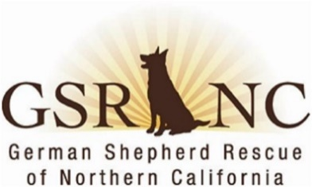
MINUTES
German Shepherd Rescue of Northern California
Board & Officers Meeting
February 18, 2026

I.& II. The meeting was called to order at 7:02 pm. In attendance:
- Patty S., President Doug G., Director & Chair
- Lee E, Director Tonya B., Director
- Joan H, Treasurer Lani C, Director
- Lorraine K. vice-president Absent: Mike M.; recording secretary: Terri M.
January 2026 minutes approved via email and now posted on website.
III. President’s report: Patty. Karen O’s recent report as director of dog ops (DDO)was discussed. 11 dogs in program. Ripley can’t handle Ads so Karen has created a large poster of Ripley to be placed in a chair at ADs. Kendall no longer adoptable and will just stay long term with her foster. Recent AC training went quite well. Allison has resigned as foster coordinator. AC coordinators returning to regional—Terri B for S. Bay, Patty for E Bay, Judy W. for Peninsula.
IV. Treasurer’s Report: Joan reported on GSRNC finances and it was agreed to move more money from checking to an interest-bearing CD. Long discussion on draft budget for 2026. Board agreed to increase the funds allotted for Board & Train and to add an additional full day clinic through Snip bus increasing it to sponsoring 5 full day day spay/neuter clinics.
IV. OLD BUSINESS
A. Update on annual meeting & elections: Patty-election materials sent to Jackie to mail out; logistics for meeting under control.
B. Website: There are problems with “contact us” link on new site—Patty to have Corbin check out.
c. Best Friends Convention: Lani, Patty, Corbin, Steve, & Matt all going. Lani was going to pay own way but Doug moved GSRNC pay for her as well; seconded by Lee—Board approved.
d. Fund-raising coordinator: Patty—no one yet, tabled for now.
V. NEW BUSINESS
A. Review of no-fee adoptions: Tonya. 6-month review reveals although there were slightly more adoptions than same period last year, far less in revenue because adopters are either not donating or donating far less than an adoption fee would have been. Joan & Lorraine proposed going back to an adoption fee at the rate it was 25 years ago when GSRNC was created. Discussion held. Lani moved & Tonya seconded, to begin 3/1/26 a flat adoption fee of $150 for all dogs, except those 10 or older (n fee for older dogs). This was unanimously approved. We will review at end of 2026. Tonya will work with Corbin to update website & Patty will inform ACs of the change. Board will keep the $100 refundable training deposit.
The Board decided not to meet in March because of the upcoming annual meeting. All agreed. Lee moved & Lani seconded to adjourn. Meeting adjourned 8:32 pm
Next Meeting Date: Tuesday, April 14, 2026, 7:00 pm
Minutes prepared by recording secretary, Terri M.

