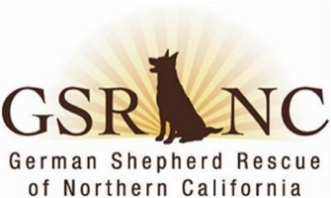
MINUTES
German Shepherd Rescue of Northern California
Board & Officers Meeting
June 9, 2026

I.& II. The meeting was called to order at 7:02 pm. In attendance:
- Patty S., President Doug G., Director
- Joan H, treasurer Lani C, chair
- Lee E, Director Tonya B., Director
- Brad A., Director Terri M., recording secretary
- Lorraine K. vice-president [ May minutes approved via email and now posted on website. ]
III. President’s report: Patty. Karen O’s recent report as director of dog ops (DDO)was discussed. Karen and Steve B. have created foster handbooks & kits for all fosters. The jobs roster has been updated and on the website. Becky is stepping down as the author of Week in Review as of 7/1/26. Need replacement to work with Jackie on that. Several ideas were discussed, in the end, board members will send suggestions to Patty by 6/12/26, on what to say in an email blast to find volunteers to fill Becky’s position as well as other positions. Raffle tickets for Wags are now for sale. Patty seeks volunteers to help with Bark in the Park on 9/19/26.
IV. Treasurer’s Report: Joan reported on finances. We are doing well. There were several large donations in May which more than offset operating expenses. However, bills for Barkley’s leg surgery ($7K) and final Best Friends expenses ($4K) will be paid in June.
IV. OLD BUSINESS
A. June 6, 2026, Contra Costa Animal Services outreach event: Brad reported that GSRNC made some good new connections, including a Lafayette pet store offering to host adoption events. Lee mentioned a Contra Costa Animal Services outreach event recently held at a dog park in Rossmoor. Lee will talk to Karen about GSRNC doing a similar event with our GSDs.
B. 25th anniversary and adoption of 5000 dogs: Tonya is working with a graphic designer on a logo for our PR and talked about how great it would be to have the 5000th dog adopted on the logo. Joan suggested getting KCBS to run a story on the 5000th dog and the milestone anniversary. GSRNC has a volunteer who works in media so Patty will reach out to that volunteer. Everyone thinks it would be great if the media could be present when the 5000th dog gets adopted.
V. NEW BUSINESS
A. Migration of former website databases to Google Drive: Tonya reported that she & Corbin are working on this and GSRNC now has a Google non-profit account. Tonya also is eager to try out Google Meetings as all board members are feeling like Free Teleconference has many glitches.
B. How to best use GSRNC resources: Tonya wants the board to consider more ways to utilize our resources. Several ideas were suggested like more low-cost spay/neuter clinics, more advertising on how much financial support GSRNC gives to fosters to encourage more fosters, take in more injured dogs, and public education. This issue will be discussed more fully at the July meeting.
Lee moved to adjourn. The motion was seconded by Doug, Brad, & Tonya. Adjourned at 8:08 pm
Next Meeting Date: Monday, July 13, 2026, 7:00 pm (NOTE: DATE CHANGE) Minutes by Terri M.

