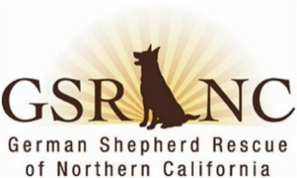
MINUTES
German Shepherd Rescue of Northern California
Board & Officers Meeting
July 13, 2026

I.& II. The meeting was called to order at 7:03 pm. In attendance:
- Patty S., President Doug G., Director
- Joan H, treasurer Lani C, chair
- Lee E, Director Tonya B., Director
- Brad A., Director Terri M., recording secretary
- Lorraine K. vice-president [ June minutes approved via email and now posted on website. ]
III. President’s report: Patty. Karen O’s recent report as director of dog ops (DDO)was discussed. Karen seeks Board approval to make Bruno an SOS dog. Doug so moved, Lee seconded, the motion carried. Board aware that Kendall passed away as Karen was taking her to the vet for emergency services. General agreement to include her story in a future newsletter.
In other news, upcoming outreach events include: 1) August 22 at Lazy Dog in Concord. The restaurant will donate to GSRNC 10% of its proceeds that day to GSRNC and will also donate to Wags; Pets on Broadway on 9/13; and 3) Bark in the Park on 9/19. New volunteer Sarah is doing a great job on the Week in Review. Trish is working on a media marketing angle for Wags and our 5000th dog adoption. Corbin is working on a link on website for people to make bequests to GSRNC.
IV. Treasurer’s Report: Joan reported on finances. The second quarter of 2026, unlike the second quarter of past years, has been a break-even quarter. During the quarter, GSRNC paid for 2 Snipbuses, insurance premiums, and expenses for two Cody Fund dogs. The organization also brought in $14K in fundraising, most of that ($11K) was from the 2027 calendar contest.
IV. OLD BUSINESS
A. 25th anniversary and adoption of 5000 dogs: Tonya is still working on the marketing end of this. There was a discussion about how best to get a photo of the 5000th dog adopted.
B. Google docs: Tonya and Corbin are working on this migration. Tonya will set up a test Google meeting invite prior to the August Board meeting to see how it works and if it is better than Free Conference Call which is used now for the Board meetings.
C. How to best use GSRNC resources: Tonya led this lively discussion. Joan suggested that more resources should be devoted to publicizing how much GSRNC does for fosters, which includes training & boarding expenses if fosters have trips planned. Board supports sponsoring more low cost spay/neuter clinics. Brad offered to talk to Mike M. about co-sponsoring a clinic and Lorraine will contact Melanie at Snipbus about setting up more clinics and in different areas of the state.
V. NEW BUSINESS
A. Creating two tiers of volunteers/members: Lani suggested creating a tier for active volunteers, who would get more recognition for their involvement, and supporting members—folks who donate but who do not actively volunteer. This will be discussed more fully at the August Board meeting.
Lee moved and Brad seconded a motion to adjourn—motion carried and meeting was adjourned at 8:09 pm.
Next Meeting: August 11, 2026, 7:00 pm (Minutes by Terri M.—recording secretary)

