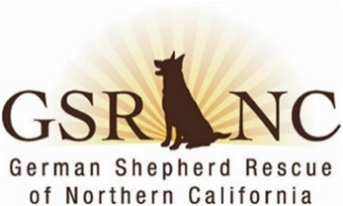
MINUTES
German Shepherd Rescue of Northern California
Board & Officers Meeting
August 11, 2026
I.& II. The meeting was called to order at 7:10 pm. In attendance:
- Patty S., President
- Joan H., treasurer Lani C., chair
- Lee E., Director Tonya B., Director
- Brad A., Director Terri M., recording secretary
- Lorraine K., vice-president Absent: Doug G.
- [ July minutes approved via email and now posted on website. ]
III. President’s report: Patty. Dog ops report was discussed. Volunteer John G. on board to become new foster coordinator & will help Karen on the administrative side. The Board gave Karen the ok to deal with/foster Darryl who is fostering Athena & Money and who has been MIA for months. Ripley will start attending ADs but must remain outside as she is reactive to dogs, she does not know. Karen has created foster binders & kits for new fosters. Tonya suggested that a photo be taken of these and then posted on Facebook. Karen also asked for a second storage unit. The Board agrees in principle and Patty/Karen will research locations and costs for such a unit in the South Bay.
Patty discussed our upcoming outreach events: 1) 8/22 at Lazy Dog restaurant in Concord; 2) 9/12-Bark in the Park in San Jose; and 3) a Santa at Danville AD in December for a photo op.
Patty reported that volunteer Joan Wheeler recently passed. There will be memorials in the Wags program for Dez Murray, Suzanne Patterson & now Joan Wheeler.
Patty also reported that she has assisted the Humboldt Sheriff’s Office in its investigation into Miranda’s Sanctuary by providing microchip and GSRNC numbers for our dogs that may have been placed there.
IV. Treasurer’s Report: Joan reported on finances. We are doing fine.
IV. OLD BUSINESS
A. 25th anniversary and adoption of 5000 dogs: Tonya. Toni M. to take photo of that adoption which will be inserted into the ad created by Tonya (thank you, Tonya). It was suggested that the Week in Review include something about the 5000th dog adopted.
B. Google Drive update: Tonya gave an update and hopes to be able to do a test run of Google meetings before the September Board meeting. Corbin is working on moving the dog archive and the donor databases over to Googel Drive.
C. tiered membership: Lani/Lorraine. There was a robust discussion on this idea but, in the end, not enough support for creating a tiered membership.
D. update on spay/neuter clinic w/SNAP: Brad/Lorraine. This is still on for October in Martinez. In the meantime, we are sponsoring Snipbus in Martinez on 8/29 and another clinic in Fresno.
V. NEW BUSINESS
Joan suggested keeping recently adopted dogs on the website for a short time to advertise our successes. Patty says that is not currently workable in Petstablished but agrees it is a good idea.
Lee moved, Tonya seconded to adjourn, mtg adjourn at 8:36 pm
Next Meeting: September 8, 2026, 7:00 pm
Minutes by Terri M., recording secretary

